Build an API with AWS API Gateway:

In this project, you build a very simple API that take two numbers and returns the product. You will need to build the following systems:

-Python code which takes two numbers “num1” and “num2” and returns the product “product” (=num1*num2).

-Lambda on AWS to run the code in the server-less framework.

-API gateway to build an API endpoint.

Here is the full workflow:

1. takes a POST request input dictionary {“num1”:num1, “num2”:num2} in JSON key value pair format, which

2. activates the lambda function, which

3. runs the python script, which

4. returns the product = num1*num2, to the API gateway

5. which returns the following dictionary {“num1”:num1,”num2”:num2,”product”:product}

Submission:

-Please send me the python code, some appropriate screenshots of the lambda and API gateway console screens (include one of the method workflow for example) to prove that AWS was used.

-Please send a sample API request and an expected response (be sure to include a few examples and all the URL info needed to test on our end). We will run this on our end

-Make sure the lambda is accessible from anywhere on the internet

-Make sure you handle errors with appropriate responses to bad input data

-As with last time, please limit your questions. Do your best to succeed without too much guidance. There are very good tutorials online.

**Steps followed in MacOSX terminal:**

1. Installed nodejs, npm, and serverless to create aws-python3 template for building the lambda function using handler and yaml files and provided event.json file as input.
   1. *sudo pip install npm*
   2. *npm install -g serverless*
   3. *serverless create --template aws-python3*
2. Build lambda function in handler.py and configure it in serverless.yml and created input in event.json
3. Added an IAM user to provide aws credentials for serverless
   1. *sls config credentials --provider aws --key yyyyyyyyyyyyyy --secret xxxxxxxxxxx*
4. Deployed the API in development environment
   1. *sls deploy --stage dev*

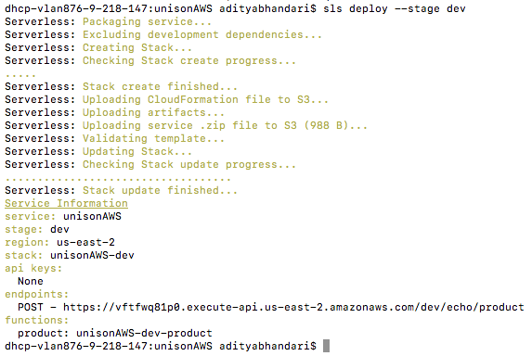

1. For testing lambda function locally in terminal
   1. *pip install python-lambda-local*
   2. *python-lambda-local -f product handler.py event.json*

